 **Eye Disease Classification**

1Omkar Singh, 2Amit Pandey, 3Chetan More,4Jeet Shah

1Head Of Department (Data Science), 2,3,4P.G. Student

1Thakur College of Science and Commerce,

1Thakur College of Science and Commerce, Mumbai-400101, Maharashtra, India

________________________________________________________________________________________________________

*Abstract:*  The proposed system is created to identify ACRIMA, Glaucoma, ODIR-5K, ORIGA, Cataract and Retina Disease in patients using Convolutional Neural Network . It estimates the effectiveness of cataract surgery as well as its safety in age-related degeneration eyes while identifying ACRIMA, Glaucoma, ODIR-5K, ORIGA, Cataract and Retina Disease . The system uses multiclass built models in combination with ROC curves to predict image output. Accuracy by Convolutional Neural Network is 94% .

*Index Terms* - Eye Disease Classification; Convolutional Neural Network, Species Classification, ACRIMA , Glaucoma , ODIR-5K , ORIGA , Cataract , Retina Disease , Convolutional Neural Network (CNN) , Detection , Machine learning techniques , Early detection , Diagnosis.

*________________________________________________________________________________________________________*

# **Introduction**

Eye disorders are increasingly prevalent in the contemporary world and affect people of all ages, including adults, children, and elderly individuals. The technologies used in diagnosis for eye diseases have far-reaching implications. That is why my main concern lies in the area of treating retinal problems, glaucoma, cataracts, ORIGA, ACRIMA and ODIR-5K. Numerous studies have been carried out on these aspects especially in relation to machine learning classification of eye diseases. For example, during one research we conducted here CNNs achieved an accuracy rate of 94%.

1. **LITERATURE REVIEW**

The research is concerned with how medical doctors can be assisted by artificial intelligence (AI) to have early diagnoses on diseases focusing on eye problems. It is true that there are a number of AI based disease detection systems in the market but they cannot all detect diseases effectively because no standard method exists in recording clinical symptoms and observations. A variety of methods, including written description and symbols, are used by medical practitioners when recording their findings which therefore require manual conversion into a standard form before being processed by computer. This limitation means that less information will be available for analysis purposes thereby causing gaps in diagnosis and prediction based on human and machine intelligence..The research proposes to help healthcare providers remain current with rapid developments in medical knowledge.[1]

This article discusses the application of image analysis and machine learning in the field of ophthalmology for automatic detection of eye cancer. It is pointed out that automation brings along cost reduction compared to human labour, fast results and better outcomes. The technology improves prognosis through early problem identification by combining machine learning with image analysis.On the same note, a different model is suggested that utilizes machine learning to categorize potential regions of cancerous cells as well as detect abnormal ocular images automatically. This approach facilitates patient-centered care, enhances diagnosis accuracy and encourages early identification. There is an indication from this study on automated eye cancer diagnosis that healthcare is being transformed by machine learning. Also operational flow diagram shows how the system works by assessing eye scans, finds any unusual structures, and later alerts doctors about possible future problems. [2]

This essay stresses the importance of early identification of retinal disease and suggests that deep learning models, such as Convolutional Neural Networks (CNNs), should be built to detect retinal eye diseases from fundus images. The suggested idea is to use it as a screening tool for early detection, especially in remote areas where this will reduce the cost for tests and travel. This section explains how datasets were collected, images were cropped and resized for further processing, image augmentation and training process, validation and testing stage for LCDNet a CNN architecture…LCDNet’s proposed architecture consists of input/output layers, convolutional layers, max pool layer and fully connected dense layers. Moreover, it lays emphasis on hyperparameter tuning which has been shown to improve DL model performance including batch size and learning rate.

When validating the system’s performance on various test sets consisting of colour images as well as red-free images at varying resolution, Furthermore some related investigations in this area have also used machine learning such as neural networks or deep learning approaches to classify or detect specific ocular disorders like age-related macular degeneration or diabetic retinopathy. [3]

The importance of DR, GLC, and AMD as the three main global causes of vision loss is discussed in the introduction. The need of early detection is highlighted by the growth in diabetes worldwide and the rising prevalence of these eye illnesses. The goal of the project is to overcome the shortcomings of the current computer-aided systems, which mostly concentrate on pairwise illness detection. Preprocessing the data and classifying the retinal images are the two stages of the suggested method. Data augmentation, k-fold cross-validation, iso-luminance plane contrast-limited adaptive histogram equalization (ISOL-CLAHE), and decreasing the region of interest are some of the methods used in data preprocessing. To provide an objective assessment of the model, the authors utilize stratified tenfold cross-validation.[4]

The importance of Optical Coherence Tomography (OCT) in the diagnosis of retinal illnesses is emphasized in the introduction, along with its use in both qualitative and quantitative evaluations. OCT measurements are essential indicators for assessing the efficacy of treatments and tracking the course of illness. Age-related macular degeneration, diabetic retinopathy, glaucoma, and diabetes mellitus are just a few of the conditions that can cause symptoms in the retina. This paper discusses the significance of deep learning approaches, namely convolutional neural networks (CNNs), in the analysis of OCT images, as well as the creation of dursen and choroidal neovascularization (CNV). The work uses CNN models to identify retinal disorders; later chapters describe the deep learning architecture, data, CNN usage, and experimental outcomes. In this study, convolutional neural networks were used to diagnose retinal disorders of the eyes using optical coherence pictures. The suggested approach was applied to the AlexNet, LeNet, and VGG-16 architectures for the purpose of classifying the preexisting dataset. The VGG-16 architecture produced an excellent classification result of 93.11% in all processing phases. However, it has been noted that loss reduction occurs when AlexNet uses the dropout layer. Future research aims to identify the distorted region by eliminating the heat map using deep learning techniques.[5].

**III. METHODOLOGY**

This particular research was aimed at detecting various eye conditions such as glaucoma, cataract, and retinal disease including ORIGA, ODIR-5K ACRIMA using state-of-the-art technologies like Convolutional Neural Networks (CNN). It also tries to find out if repairing cloudy lenses is a safe and effective way of addressing aging eyes which are becoming weak. The multiclass ROC curves are used to refine image output prediction results based on popular models.

It starts with extensive preprocessing of the data that involved taking high definition ocular images. Then Convolutional Neural Networks are used to extract features associated with Retinal problems, glaucoma, cataracts, ORIGA, ACRIMA or ODIR-5K. CNN has an outstanding accuracy rate of 94%..

**Fig.1. Flow Chart of Eye disease Classification using CNN**

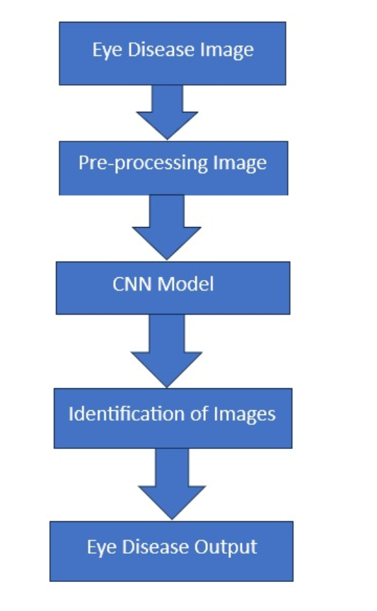

**IV. RESULTS**

The suggested hybrid system demonstrates high-performance in diagnosing patients with ACRIMA, Glaucoma, ODIR-5K, ORIGA, Cataract and Retinal Disease through Convolutional Neural Network (CNN) . This method is a combination of Convolutional Neural Network (CNN) .which is good for comprehensive detection of diseases while the CNN model has a slightly higher 94%. Through the use of multiclass models and ROC curves, this system also helps to improve on image output predictions as well as study the effectiveness of cataract surgery among eyes having age-related degeneration. In literature review, there is much focus on AI in early disease detection with the proposed hybrid approach at reviews taking cognizance of weaknesses in clinical observations. Optical Coherence Tomography(OCT) interpretation in retinal diseases needs machine learning techniques such as CNNs especially when VGG-16 achieves an impressive 93.11% classification accuracy.

|  |  |  |
| --- | --- | --- |
| Epochs | Accuracy | Validation |
| Epoch 1/5 | 83% | 93% |
| Epoch 2/5 | 92% | 95% |
| Epoch 3/5 | 93% | 94% |
| Epoch 4/5 | 94% | 92% |
| Epoch 5/5 | 94% | 94% |

**Figure.3(A) shows the accuracy of CNN**

**V. CONCLUSION**

Better eye classification has been achieved through the hybrid approach, a combination of Convolutional Neural Network (CNN) .CNN model accuracy slightly higher at 94%. This clearly indicates that this is a very accurate process in terms of its diagnostic comprehensiveness. Predictive though put is increased when using multiclass models and ROC curves for assessing efficiency of cataract surgery in eyes suffering from age-related degeneration. Some limitations associated with clinical observations are therefore addressed by this hybrid approach since there have been no reliable biomarkers to distinguish between early onset and slow progression diseases. Optical Coherence Tomography was used by retinal disorders which identified more than 93.11% classification accuracy especially when source images were obtained inform VGG-16 via the CNNs. In summary, it can be inferred that the mixed system offers better potential for improving precise as well as dependable ocular diagnosis.

**VI. REFERENCES**

1. Malik S, Kanwal N, Asghar MN, Sadiq MAA, Karamat I, Fleury M. Data Driven Approach for Eye Disease Classification with Machine Learning. Applied Sciences. 2019; 9(14):2789.
2. Mistry, Jinal, and Rakesh Ramakrishnan. "The Automated Eye Cancer Detection through Machine Learning and Image Analysis in Healthcare." Journal of Xidian University 17.8 (2023): 763-763.
3. L. Jain, H. V. S. Murthy, C. Patel and D. Bansal, "Retinal Eye Disease Detection Using Deep Learning," 2018 Fourteenth International Conference on Information Processing (ICINPRO), Bangalore, India, 2018, pp. 1-6, doi: 10.1109/ICINPRO43533.2018.9096838.
4. Chea, Nakhim, and Yunyoung Nam. "Classification of Fundus Images Based on Deep Learning for Detecting Eye Diseases." Computers, Materials & Continua 67, no. 1 (2021).
5. M. E. Sertkaya, B. Ergen and M. Togacar, "Diagnosis of Eye Retinal Diseases Based on Convolutional Neural Networks Using Optical Coherence Images," 2019 23rd International Conference Electronics, Palanga, Lithuania, 2019, pp. 1-5, doi:10.1109/ELECTRONICS.2019.8765579.